INFX 1606
Assignment 1

Name: YIDE GE
Student ID: B00639491

A 1.1. The website is www.dal.ca. This website’s user have several characteristics: most of them are students, they using this website access to Dalhousie university’s information.

A 1.2.
Visibility of system status
Dal.ca system responses effectively.

Match between system and the real world
Yes. Dal.ca has numerous really world news update. Without any non-English word.

User control and freedom
Dal.ca did very well, users can easily undo and redo.

Consistency and standards.
Dal.ca have many thing is same with most website, users can easily know what is mean. Like ‘about dal’ ‘events’ ‘news’

Error prevention
Not observed any error on dal.ca

Recognition rather than recall
The information on Dal.ca was great organized.

Flexibility and efficiency of use
Not observed

Aesthetic and minimalist design
The information on dal.ca were great organized and some part of information were minimalist.

Help users recognize, diagnose, and recover from errors
Not observed

Help and documentation
Not observed

A 1.3.
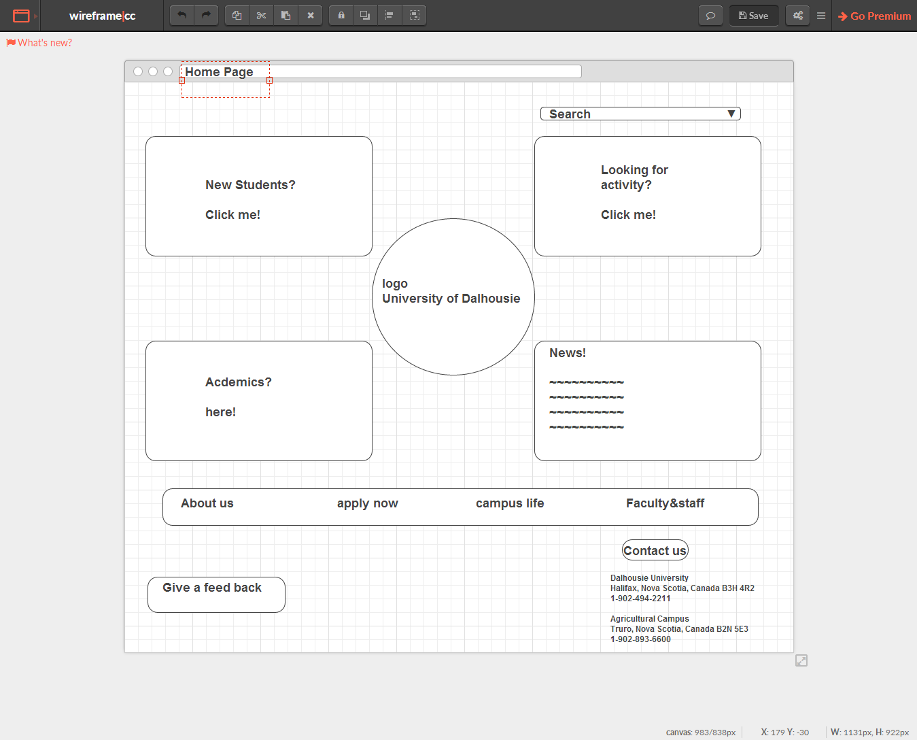
https://wireframe.cc/MMM70Q
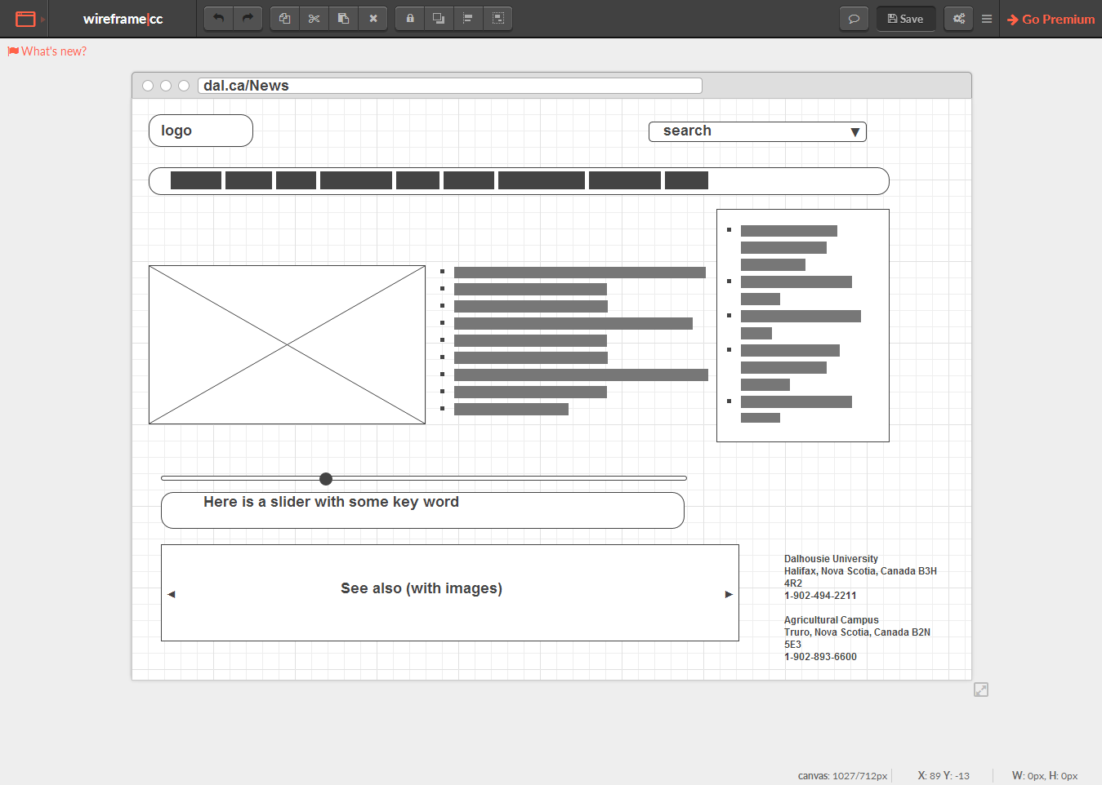
https://wireframe.cc/FhRoax

